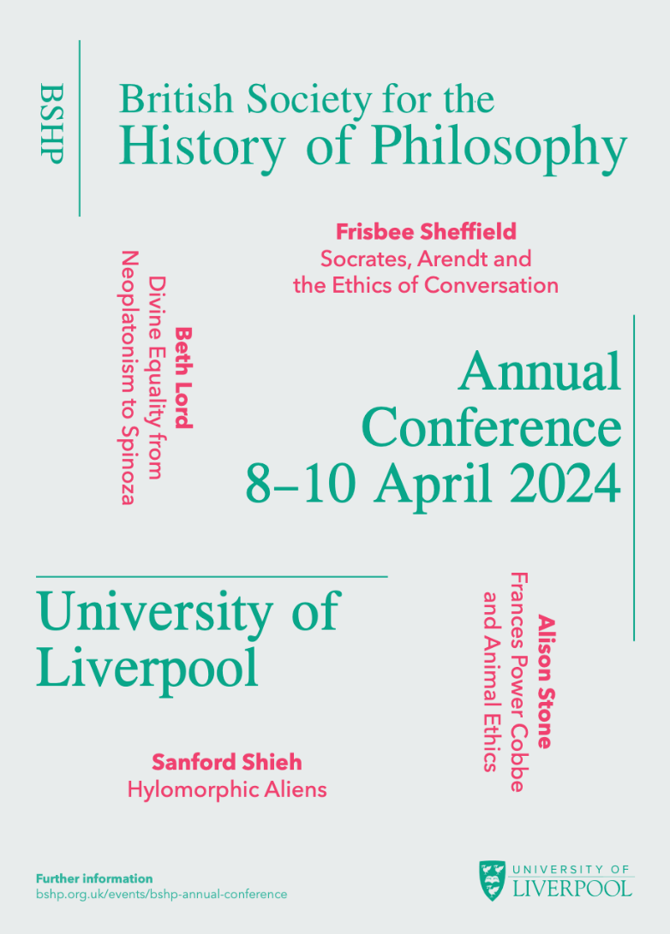
BSHP Annual
Conference
2024

The University of Liverpool Philosophy Department is delighted to welcome you to the British Society for the History of Philosophy’s Annual Conference. Sessions will take place across four lecture theatres and a GLEX space, with registration and refreshments in the Atrium, all within the Central Teaching Hub.

Day 1: Monday 08/04/2024

TIME | Lecture Theatre A | Lecture Theatre B | Lecture Theatre C | Lecture Theatre D | G-FLEX | Atrium
12:00 |  |  |  |  |  | REGISTRATION
12.30 | WELCOME
13:00 | KEYNOTE 1 FRISBEE SHEFFIELD  Socrates, Arendt & the Ethics of Conversation
14:30 |  |  |  |  |  | COFFEE
15:00 |  | PANEL 1  SMRP: Merging of Traditions | PANEL 2  Women on Logic & Language in the c20th | PANEL 3*  Tito Magri’s Hume’s Imagination (with opening & closing comments from Magri) | PANEL 4 Transcendental Freedom & Experience (with extra discussion)
17:00 |  |  |  |  |  | END
18:00 |  |  |  |  |  | CONFERENCE DINNER (LEAF)

Day 2: Tuesday 09/04/24

TIME | Lecture Theatre A | Lecture Theatre B | Lecture Theatre C | Lecture Theatre D | G-  FLEX | Atrium
09:30 | KEYNOTE 2:  BETH LORD  Divine Equality from Neoplatonism to Spinoza
11:00 |  | PANEL 5  SMRP: Logic & Science | PANEL 6  SSHAPP: Anscombe vs Austin | PANEL 7  Neglected Early Modern Minds: Cordemoy, Cavendish & Baxter | PANEL 8  Science vs Philosophy
13:00 |  |  |  |  |  | LUNCH
14:00 |  | PANEL 9  SMRP: Metaphysics & Epistemology | PANEL 10  SMRP: Metaphysics & Epistemology | PANEL 11  Common Notions, Universal Experience in C17th Natural Philosophy | PANEL 12  Identity, embodiment, & second nature in Cavendish, Spinoza, & Hegel
15:30 |  |  |  |  |  | COFFEE
16:00 |  | PANEL 13  SMRP: Powers | PANEL 14  ‘Common Sense’ arguments against anti-realism | PANEL 15  Puzzles about Shape | PANEL 16  Hegel
17:30 | KEYNOTE 3:  ALISON STONE  Frances Power Cobbe and Animal Ethics

Day 3: Wednesday 10/04/2024

TIME | Lecture Theatre A | Lecture Theatre B |  | Lecture Theatre C |  | Lecture Theatre D | G-  FLEX |  | Atrium
09:00 |  |  |  |  |  |  |  | COFFEE
09:30 |  | PANEL 17  Ancient moral & political thought | PANEL 18  Anscombe's The First Person |  | PANEL 19  Sympathy & Virtue |  | PANEL 20  Virtuous Epistemology
11:00 |  |  |  |  |  |  |  | COFFEE
11:30 |  | PANEL 21  Ancient Logic & Science | PANEL 22  First & Second Nature |  | PANEL 23  Mary Shepherd’s Realism |  | PANEL 24  Evaluating Liberalism
13:30 |  |  |  |  |  |  |  | LUNCH
14:30 | KEYNOTE 4:  SANDFORD SHIEH  Hylomorphic Aliens
16:00 |  |  |  |  |  |  |  | COFFEE
16:30 | AGM

PANELS

 | PANEL NAME | Paper 1 | Paper 2 | Paper 3 | Paper 4
1 | Sym: Merging of Traditions (SMRP) | TATIANA BARKOVSKIY  Marguerite Porete on the epistemically and ontologically transformative dimension of love | JACK ZUPKO  Certitude, Firmness, and Truth: The Psychology of Knowing in John Buridan | MASSIMILIANO TININI  Bible and Exegetical Tradition in Yehudah Abarbanel’s Dialoghi d’amore" | AMOS EDELHEIT  Florentine Aristotelianism and Scholasticism in the Renaissance: The Case of Niccolò Tignosi (1402-1474)
2 | Sym: Women on Logic & Language in the c20th | SIOBHAN CHAPMAN  Helen Knight on language and art | SOPHIA CONNELL  Alice Ambrose’s philosophical method | MAHESHI GUNAWARDANE  Susan Stebbing as a foremother of informal logic | FREDERIQUE JANSSEN-LAURET  Ruth Barcan Marcus’ contributions to modal logic
3 | Sym: Tito Magri’s Hume’s Imagination* | TITO MAGRI  Opening remarks & responses | MARINA FRASCA-SPADA  The point of view on the Treatise, Book 1 in Tito Magri’s Hume’s Imagination | P. J. E. KAIL  Animals and Naturalism and Hume’s Imagination: Comments on Tito Magri’s Hume’s Imagination | ALESSIO VACCARI  Hume's Idea of the Self and Personal Identity: Comments on Tito Magri’s Hume's Imagination
4 | Sym: Transcendental Freedom & Experience | LUCIA VOLONTÉ  Kant on Transcendental Freedom: An Analysis of the Notes on Metaphysics from 1760s | ÁLVARO R. G. BARREDO  How to find a free being: reflective judgment and the sensible signs of freedom | JOE SAUNDERS  Invisible Freedom: Epistemic and Practical Problems with Kant’s Theory of Freedom
5 | Sym: Logic & Science (SMRP) | PETER EARDLEY  Theology and the Parts of Logic in Later Medieval Philosophy | PREE JAREONSETTASIN  How to decompose an essence: Kilwardbian genus-differentia definition in context | MOHAMMAD SALEHZAREPOUR  (Recipient of the Founders' Award in 2022)  Dashtakī's Solution to the Liar Paradox: A Synthesis of the Earlier Solutions Proposed by Ṭūsī and Samarqandī
6 | Symp: Anscombe vs Austin (SSHAP) | SOFIA MIGUENS  ‘I will show you things we humans do’—Where Anscombe and Austin diverge | JEAN-PHILIPPE NARBOUX  Assertions and Performatives: Anscombe vs. Austin | DAVID ZAPERO  A Difference of Form | EYLEM ÖZALTUN  Two Ways of Taking the Ordinary Seriously
7 | Panel: Neglected Early Modern Minds: Cordemoy, Cavendish & Baxter | TOBIAS SANDOVAL  Going through the motions: Memory and Remembrance in Cavendish | ANNA ORTÍN NADAL  Cordemoy and the Cartesian analogy between language and perception | DAVID BARTHA  Baxter on Dreams, Imagination, and Common Sense
8 | Panel: Science vs Philosophy | ALESSANDRO TAVERNITI  Before and After Cousin. From the Construction of a Historiographical Model to the Rising of a New Image of Philosophy in Nineteenth-Century France | FILIP ADOLF A. BUYSE  B. Spinoza and J.P. Müller: The Dutch Philosopher and the German Physiologist | PETER WEST  ‘Philosophy is not a science: Margaret Macdonald on the nature of philosophical inquiry’ | JEREMY DUNHAM  William James, François Pillon, and Charles Renouvier on the Uncritical Assumptions of the Natural Sciences
9 | Symp: Metaphysics & Epistemology (SMRP) | ZITA V. TOTH  Creation and causal powers in the Early Scholastic tradition | ERMAN KAR  Evaluation of the Problem of Universals in the Medieval Age with Aristotelian Realism | PETER JOHN HARTMAN  Varieties of Anti-representationalism in the High Latin Middle Ages
10 | Sym: Women & Logic in the C20th | TERESA KOURI KISSEL  Susan Stebbing's Common Sense Approach to Critical Thinking | GIULIA FELAPPI  “Please let me know whether it seems to you absurd or ridiculous to bring in necessity”: Dorothy Wrinch on the all-important role of logic
11 | Sym: Common Notions, Universal Experience in C17th Natural Philosophy | NIALL DILUCIA  “A most plaine and easie conception wherein all mankind naturally agreeth”: Common Notions and the Role of Understanding in Sir Kenelm Digby and Thomas White | LOUIS ROUQUAYROL  The Three Sources of Ordinary Experiences: A Baconian Legacy | ERIC SHENG  John Sergeant on Natural Notions and Common Heads
12 | Sym: Identity, embodiment, and second nature in Cavendish, Spinoza, and Hegel | LUCE DE LIRE  We are all hermaphrodites! A Cavendishian intervention | OLIVER TOTH  Turning passions into actions in Spinoza’s philosophy | MARTINA BARNABA  Humans and their Embodiment: Hegel’s Habitus between First and Second Nature
13 | Sym: Powers SMRP | JOSÉ FILIPE SILVA  Active potency of matter ca. 1240-1280 | CAN LAURENS LÖWE  Albert the Great on the Soul as Operation | ANDRÉ MARTIN  (Recipient of the Founders' Award in 2021)  The Activity of the Soul and the Causality of its Objects: Gonsalvus of Spain and the Influence of Peter John Olivi
14 | Panel: 'Common Sense' arguments against anti-realism | EMILY THOMAS  G. E. Moore’s Common Sense Time Realism, Presentism, and A Theory | ANDREAS VRAHIMIS  Stebbing's critique of anti-realism
15 | Panel: Puzzles about Shape | SZILVIA SZANYI  Is Shape Real? Controversies over the Nature and Reality of Shape in the Works of Vasubandhu and his Commentators | YINING WU  The Shape of Water -- Conway’s Interpretation on Water and The Conception of Corporeality
16 | Panel: Hegel | LAURI KALLIO  The logical course of history. Ferdinand Lassalleand late Hegelianism | TATIANA LLAGUNO NIEVES  Redressing our Relation to Nature: The Ethical Vision of Hegel’s Causality of Fate
17 | Panel: Ancient moral and political thought | MATTHEW DUNCOMBE  The Origins of the Liar, the Sorites, and Some Less Popular Paradoxes | I XUAN CHONG  Practical truth and the unity of virtues in Aristotle
18 | Sym: Anscombe's The First Person | MARIE MCGINN  Wittgenstein and Anscombe on 'I' | SOPHIA ARBEITER  Between the A-users and the solipsist | MADELEINE LEVAC  Anscombe's positive account of I-thoughts
19 | Panel: Sympathy and Virtue | KEITH GREEN  Sophie du Grouchy and Adam Smith on Sympathy with Hatred | ALESSIO VACCARI  Mill's Notion of Virtue. Duty, Sympathy, and Well-Being
20 | Symp: Virtuous Epistemology: Coming to know the world through Limits | ERIN CHOI  The Significance of the Platonic Theory of “Limit” for Contemporary Virtue Epistemology | MUHAMMAD SAMI  Humility and the limiting nature of forms in Jāmī | ADHAM EL-SHAZLY  Humility and the Limits of Moral Understanding in Iris Murdoch
21 | Panel: Ancient Logic and Science | BENJAMIN WILCK  Why a Point Cannot Be Part of a Line: Mereology in Aristotle and Euclid: Mereology | MARIANE OLIVEIRA  Scientific method, “pre-scientific notions”, and nominal definitions on Aristotle’s Posterior Analytics | ÁKOS TUSSAY  Stasis and logismos in Archytas’ thought | ANDREA BUONGIORNO  Being per se being per accidens in Metaphysics Δ7
22 | Panel: First and Second Nature | ELLIE ROBSON  Mary Midgley and Neo-Aristotelian Naturalism | EVAN THOMAS  Different Knowledges in Different Kinds and Sorts of Creatures: Cavendish Against Descartes on Animal Minds | KONSTANTINOS CHATZIGEORGIOU  Naturalising the Mind and Spiritualising Nature: F. J. E. Woodbridge and The Objective Mind
23 | Sym: Mary Shepherd's Realism | CLARE ETCHEGARAY  Shepherd’s Criticism of Reid’s Theory of Perception | BENOÎT GIDE  Shepherd’s Analysis of Natural Confusions in Perception | RAPHAËL PIERRES  Shepherd's Refutation of Idealism | PIERRE-LUC DESJARDINS  The Use and Meaning of Analogy in Mary Shepherd’s Thought
24 | Panel: Evaluating Liberalism | THOMAS SCHRAMME  Wilhelm von Humboldt's theory of individuality | HINA NAZAR  Mary Astell and John Locke: A Revaluation | TOM BAILEY  Kant and the Settler Contract | RUBEN NOORLOOS  Van den Enden on Chattel Slavery

